Your first and last name*: | Recorder’s name (if different to your own): | 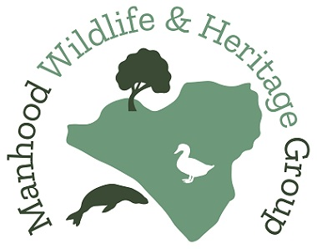
Wildlife Records
Date* | Nearest postcode*/ WGS84 Coordinates* | Environment* & habitat (farmland, garden, pond etc.) | Species common name* & Latin name | No. seen* | Adult / sub-adult / unknown? * | Male / female / unknown? * | Comments, observations, photo file name (required if photo taken)

